EX 1 THREE-LAYER NEURAL NETWORK FROM SCRATCH DATE:

Problem Statement:
Design and implement a three-layer neural network from scratch using Python. Train the network using the backpropagation algorithm with appropriate activation and loss functions. Apply the model to recognize handwritten digits using the MNIST dataset.
Objectives:
- Understand the structure and working of a basic feedforward neural network.
- Implement forward propagation and backpropagation from scratch.
- Use the sigmoid activation function and cross-entropy loss.
- Train the model on the MNIST dataset and evaluate the loss over epochs.
- Visualize training performance and perform predictions on sample images.
Scope:
This experiment demonstrates the core principles behind neural networks and training them using backpropagation. It is foundational for understanding deep learning and how more complex models (like CNNs or Transformers) build upon this architecture.
Tools and Libraries Used:
- Python 3.x
- NumPy
- Matplotlib
- TensorFlow (for dataset loading)
- scikit-learn (OneHotEncoder)

Implementation Steps:
Step 1: Import Necessary Libraries
import numpy as np import matplotlib.pyplot as plt from tensorflow.keras.datasets import mnist
from sklearn.preprocessing import OneHotEncoder

Step 2: Load and Preprocess the Dataset
(X_train, y_train), (_, _) = mnist.load_data() X_train = X_train.reshape(-1, 784) / 255.0 encoder = OneHotEncoder(sparse_output=False) y_train = encoder.fit_transform(y_train.reshape(-1, 1)) Step 3: Initialize the Network
input_size, hidden_size, output_size = 784, 64, 10 W1 = np.random.randn(input_size, hidden_size) * 0.01 b1 = np.zeros((1, hidden_size))
W2 = np.random.randn(hidden_size, output_size) * 0.01
b2 = np.zeros((1, output_size))

Step 4: Define Activation and Loss Functions
sigmoid = lambda x: 1 / (1 + np.exp(-x)) sigmoid_deriv = lambda x: x * (1 - x) loss_fn = lambda y, y_hat: -np.mean(y * np.log(y_hat + 1e-8))

Step 5: Train the Model
epochs, lr = 10, 0.1 losses = [] for epoch in range(epochs):
total_loss = 0 for i in range(X_train.shape[0]):
- = X_train[i:i+1]
- = y_train[i:i+1]

z1 = x @ W1 + b1 a1 = sigmoid(z1) z2 = a1 @ W2 + b2 a2 = sigmoid(z2) loss = loss_fn(y, a2)
total_loss += loss

dz2 = a2 - y dW2 = a1.T @ dz2
db2 = dz2

dz1 = (dz2 @ W2.T) * sigmoid_deriv(a1)
dW1 = x.T @ dz1
db1 = dz1

W2 -= lr * dW2 b2 -= lr * db2 W1 -= lr * dW1
b1 -= lr * db1
losses.append(total_loss / X_train.shape[0])
print(f"Epoch {epoch+1}, Loss: {losses[-1]:.4f}")

Step 6: Visualize Training Loss
plt.plot(losses)
plt.title("Training Loss") plt.xlabel("Epoch") plt.ylabel("Loss") plt.grid(True)
plt.show()

Step 7: Predict a Sample Digit
def predict(img):
img = img.reshape(1, 784) / 255.0 a1 = sigmoid(img @ W1 + b1) a2 = sigmoid(a1 @ W2 + b2)
return np.argmax(a2)

idx = 100 plt.imshow(X_train[idx].reshape(28, 28), cmap='gray') plt.title(f"Prediction: {predict(X_train[idx])}") plt.axis('off')
plt.show()

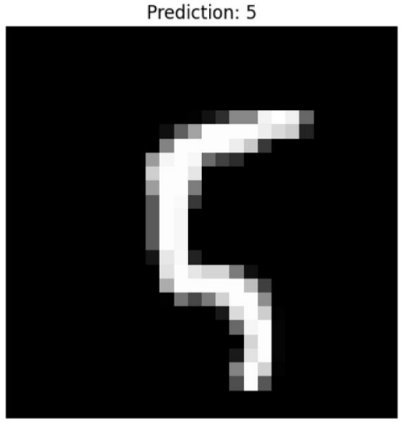

Conclusion:
This experiment successfully demonstrates the manual implementation of a basic threelayer neural network. Through backpropagation and weight updates using gradient descent, the model learns to classify handwritten digits. It emphasizes key deep learning concepts such as feedforward computation, loss minimization, and numerical stability in gradient calculations.

